ECE 387 Written Proposal

Main Component Required

Camera Module

Light sensor

Wireless Module

Touch Screen Module

Buzzer

LED Light

Servo-motor

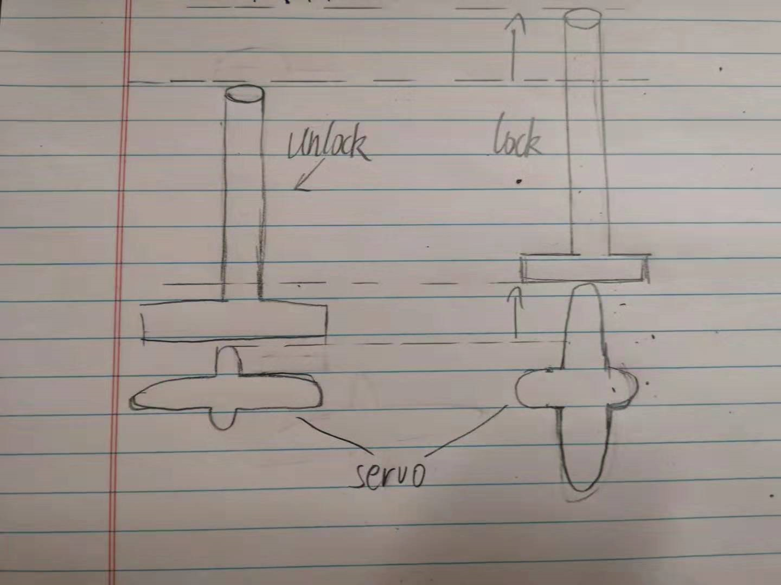

**Overview**

The Goal of Final Group Project is creating a smart locker which consist with remote unlock ,password unlock basic function and a security system.

**Unlocking**

There will be two option : password unlock and remote unlock. Password can be set with touch screen and store the new generate password in flash memory. Remote control can be done by mobile device, no password required. When the locker is unlocked , Green LED would turn on. Disarm the security system.

**Lock**

The lock can be controlled by Servo-motor. When the lock is “on”, Red LED light would turn on indicating the locker is occupied.

**Security system**

Security system is about ring the siren and capture face of suspect with camera when the locker is opened by force. A light sensor would embedded in the locker and trigger the alarm if password or remote command are not correctly implement. The alarm will not be triggered if password or remote is not set up properly (Or ready)

**Additional Function(Uncertain)**

UI improvement

User can choose the unlocking method with a control panel.(Touch Screen or Button).

Sound Recording

When the alarm is triggered, not just capturing the image of suspect , but record the voice for 10-30 Sec after security breach.

Expecting Outcome

Milestone

Mar 15

Research should been done. Purchasing the missing material online.

Mar 25

Get everything prepared(Material)

Apr 5

Lock and unlock part finished

Apr 12

Security system work properly

Apr 15

Modules function normal in separate

Apr 20

Assemble the Modules

Apr 25

Finishing Debug

Apr 30

Finish the Report